TEACHERS DAY REPORT

Dr. Ambedkar College Deekshabhoomi, Nagpur
Department of Law Academic Session 2022-23
Teachers Day Report

Name of the Programme: Teachers Day Celebration
Day & Date : Tuesday, 6th September’2022
Time & Venue : 12pm, Dr. Ambedkar College
Department of Law, Nagpur

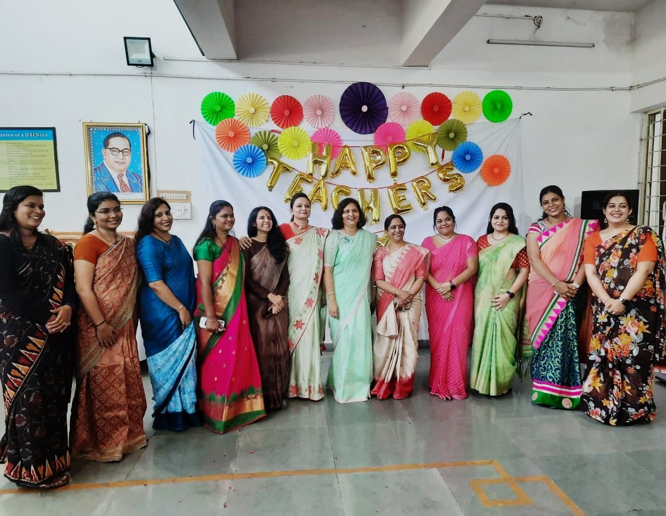
"Teachers are the torch bearers of the Gen-next"
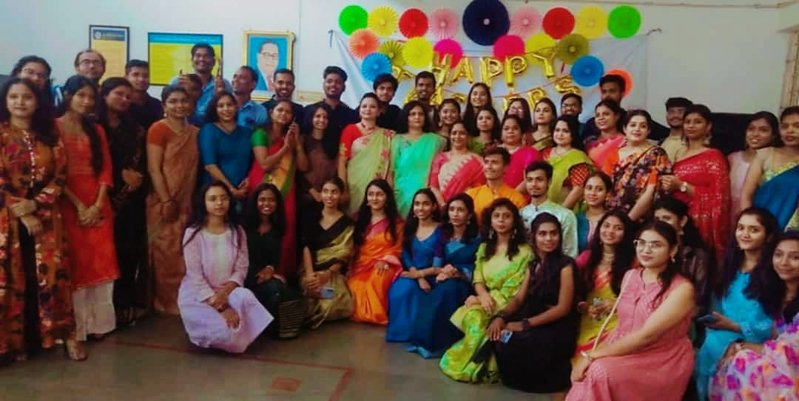
In India, 5th September is celebrated as Teachers Day as a mark of tribute to the contribution made by teachers to the society. 5th September is the birthday of a great teacher Dr. Sarvapalli Radhakrishnan, a staunch believer of education and a well-known diplomat, visionary, statesman, scholar, President of India and above all a perfect Teacher.
Teacher's day was celebrated by the students of Law Department on 6th September to express their gratitude for the immense contribution put forth by their teachers towards their development. Students decorated the college campus and welcomed the faculties warmly.
The celebration began with a traditional offering of devotion to Lord Buddha and Dr. Babasaheb Ambedkar with garlanding of their portraits and lighting the candles by the Head of the Department, Mrs. H.V. Menon and all other faculties. Further, each of the faculties were given a token of gratitude to show the acknowledgement and recognition of the hard work put by the teachers, wishing them a Happy Teachers Day.
A student of 3rd Year from the 3 Years course then delivered a speech on the importance of teachers in one’s life and the concept behind the celebration of Teachers Day. Her speech gave an enthusiastic start to the celebration. Then the students conducted games like Dumb charades & Quizzes and other recreational activities among the teachers to engage them and showcase a great deal of bond which goes beyond work colleagues. Unlike any other monotonous workday, the students wanted the day to be very free flowing and relaxing for the teachers. So, students and the teachers participated in singing beautiful melodies for a change.
The Head of the Department, Dr. H.V. Menon then addressed the audience by admiring all the hardwork and the wonderful collaborations by the students throughout. She also acknowledged all the contribution made by everybody for the collective upliftment of the department.
After all the hush & bush from the recreational activities, the enthusiasm in the room was still there. So, we finally settled down to celebrate this auspicious day by cutting the cake by the teachers & a session of photography commenced thereafter.
The vote of thanks was delivered by Ms. Unnati Bobde a student of final year. She whole heartedly extended her sincere wishes to all the teachers and thanked everybody for their presence. Teachers Day was celebrated with a lot of anticipation, for the sheer spirit of the occasion. The event was concluded by the reviews of the Department and all the faculties.

